Project Schedule Assignment

Husky Air Database Management

07/18/2022

***Group 2***

***Nitish Katkoori (Z1942695)***

***Srikanth Reddy Narra (Z1947038)***

***Tianyu Nan (Z1831431)***

Contents

Network Diagram 3

Table

Task List

Gantt Chart

## Network Diagram

|  |  |
| --- | --- |
| Activity | Activity ID |
| Analysis Phase | A |
| Application Designing | B |
| Web Page Design | C |
| Backend Code Development | D |
| System Interfacing | E |
| Data Maintenance and Migration | F |
| Quality Analysis/ Testing | G |
| Deployment | H |
| Maintenance | I |

## Table

## PERT Analysis:

|  |  |  |  |  |  |  |  |  |
| --- | --- | --- | --- | --- | --- | --- | --- | --- |
| Activity Identifier | Activity Name | Start Date | End Date | Predecessor | Most Likely Date | Optimistic Time | Pessimistic Time | PERT |
| A | Analysis Phase | 05/14/22 | 06/10/22 |  | 21 | 18 | 23 | 20.83 |
| B | Application Designing | 06/11/22 | 06/14/22 | A | 3 | 2 | 4 | 3 |
| C | Web Page Design | 06/15/22 | 07/13/22 | B | 21 | 17 | 26 | 21.16 |
| D | Backend Code Development | 07/14/22 | 09/13/22 | B | 44 | 42 | 48 | 44.33 |
| E | System Interfacing | 09/14/22 | 10/06/22 | C, D | 17 | 15 | 20 | 17.16 |
| F | Data Maintenance and Migration | 10/07/22 | 10/20/22 | E | 10 | 8 | 14 | 10.33 |
| G | Quality Analysis/ Testing | 10/21/22 | 11/14/22 | F | 17 | 14 | 22 | 17.33 |
| H | Deployment | 11/15/22 | 11/21/22 | G | 5 | 4 | 8 | 5.33 |

## Task List

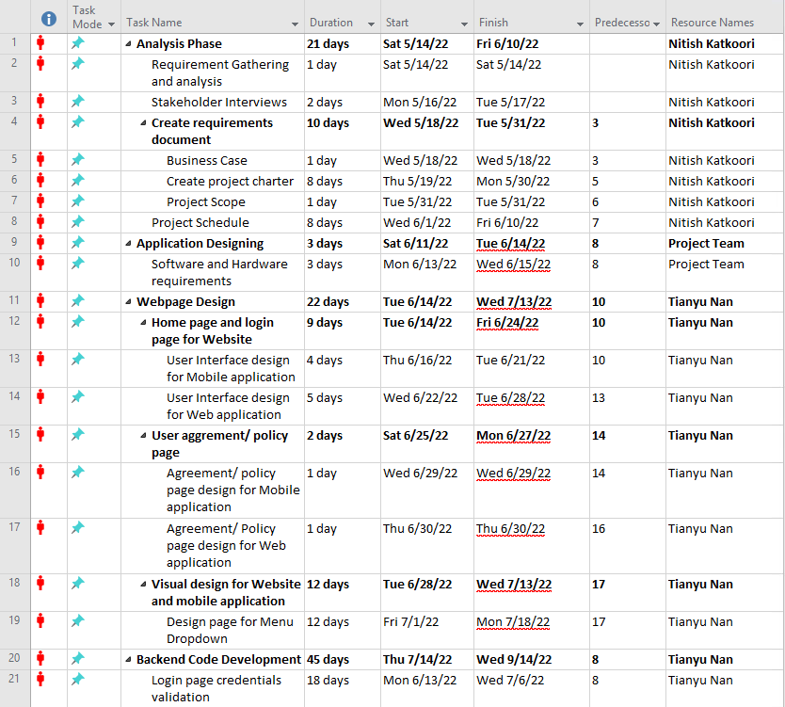

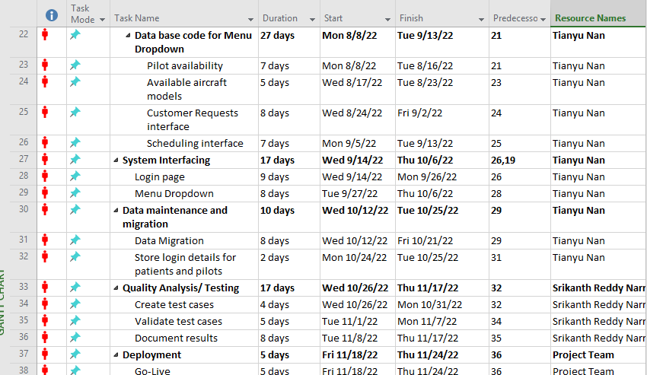

## Gantt Chart

